AMENDMENT #3 TO NOR #2 TO THE SAILING INSTRUCTIONS

Amendment to NOR
NOR 11.3 is deleted and replaced by: Competitors who did not finish one leg or have been disqualified will not be allowed to start the following leg. A boat that did not finish within the time limit will be scored as DNF. Even if the leg is cancelled later on, the boats that retired or did not sail the course will not be allowed to start the following leg.
NOR 13 is deleted and replaced by : A breach of rules may, after a hearing, be given a penalty in time.
Amendment 2 to the NOR is deleted and replaced by :
2.11 Alternative Starting Penalties
Under World Sailing Development Rule DR21-01, change the definition Start as follows:
Start A boat starts when her hull having been entirely on the pre-start side of the starting line, and having complied with rule 30.1 if it applies, any part of her hull crosses the starting line from the pre-start side to the course side either
(a) at or after her starting signal, or
(b) during the last minute before her starting signal.
When a boat starts in accordance with item (b) of the definition Start, she may return to the pre-start side of the line to comply with item (a) of the definition of Start, but, if she does not the starting penalty shall be 24 hours added to her elapsed time on the concerned leg
Rules 30.1 and 30.2 are replaced as follows
If flag Z+I has been displayed as preparatory signal, no part of a boat’s hull shall be in the triangle formed by the ends of the starting line and the first mark during the last minute before her starting signal.
If a boat breaks this rule and is identified:
- 12h shall be added to her elapsed time on the concerned leg without a hearing. She shall be penalized even if the race is restarted or resailed, but not if it is postponed or abandoned before the starting signal. If she is similarly identified during a subsequent attempt to start the same race, additional 12h shall be added to her elapsed time on the concerned leg.
- She shall sail across an extension of the starting line so that her hull is completely on the pre-start side before she starts; if she returns to the pre-start side of the starting line by sailing through the line without crossing the extensions of the line, 12h shall be added to her elapsed time on the concerned leg without a hearing.

Amendment to Sailing Instructions

Replace in all SI :
“Offshore Special Rules (OSR)” by “Offshore Special Regulation (OSR)”
“Chapter 2 rules of the RRS” by “Part 2 of the RRS;
“COLREG” by “IRPCAS (International Regulations for Preventing Collisions at Sea);
“Traffic Separation Systems” by “Traffic Separation Scheme”
10.1
Replace “must” by “shall”
11.2
Replace “must” by “shall”
13.3
Delete and replace by:
Experimental rule DR21-01 applies as described in NOR Amendment 3.
While displaying X flag, the Race committee may inform boats identified On the Course Side by communicating her sail number on Channel U77.
the absence of VHF transmission or reception will not be ground for redress (this changes RRS 62.1(a).

15.1
Delete and replace by:
When RRS Part 2 rules do not apply and are replaced with Part B of the Section II of the IRPCAS, the boat Shall take a two turns penalty.
17.5 : replace “this changes RRS 60.1” by “This changes RRS 66.2”.
20.3
Read
Only the set of sails declared at the start may be used during the event. Any sail replacement during the event will be subject to a 24-hour penalty (Class Rule E-25-a).
System of energy production cannot be changed during the event. Any change noted by the technical committee will be subject to a 24-hour penalty (Class Rule E-25-b).

APPENDIX 3 – Leg 1
14.1 FINISH

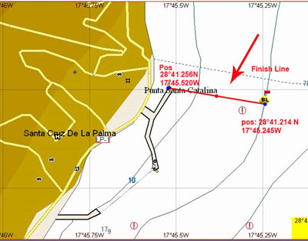
Finish line

President of the Race Committee President of the Jury

Patrick MAURIN Sylvie HARLE

Posted on 09/22/2023 at 06:00 pm

